**Student Name:**

**Student ID:**

**CPD Assessment Questions**

Once complete, please Submit a **single**PDF of your completed Template with the filename in the form <LastName_FirstName_ StudentID>.pdf.

**Please use examples from your Engineering-related experiences as a priority when completing these questions.**

Learning outcomes for the CPD unit can be found in the Monash University Handbook: [ENG0001](https://handbook.monash.edu/2023/units/ENG0001) is the unit code for Bachelor of Engineering (Honours) students and [ENG0003](https://handbook.monash.edu/2023/units/ENG0003) is the unit code for Master of Professional Engineering students.

There are a number of examples of [answers to these CPD Assessment Questions posted on the website](https://www.monash.edu/engineering/current-students/professional-development/continuous-professional-development/cpd-exemplars) to assist you with understanding what high quality answers look like. These exemplars are to act as a guide only and should not be copied. CPD is an academic unit, and as such falls under Monash’s [Student Academic Integrity Policy](https://publicpolicydms.monash.edu/Monash/documents/1935762).

When you submit your CPD for assessment it will be checked by TurnitIn for plagiarism, and the Faculty of Engineering also audits CPD submissions every semester to ensure there are no academic integrity issues.

|  |
| --- |
| **CPD Section 1: *Ethics and Professional Accountability***  Drawing upon your CPD experiences (Engineering-related preferred), provide examples for two of the following situations.  **Part 1:**  1. A situation where you had to consider your actions in terms of **ethical conduct**, specifically relating to the Engineers Australia Code of Ethics (Page 4). **(250 words) You must** [**download the code here and read it.**](https://www.engineersaustralia.org.au/ethics) |
| **Which one of the four behaviours from the Code of Ethics are you describing?**  **Which sub-point are you describing? Please cut and paste the full text from the sub-point.**  **Describe a situation where you considered your actions in these terms?**  Word Count: ???  Minimum Words = 150  Maximum Words = 250 |
| **Assessors Comments:** |
| **Part 2**  **(choose only 1 of the following situations):**   1. A situation where you had to consider whether **due diligence** had been applied in relation to risk management compliance. 2. A situation where you had to consider the **safety of other people**. 3. A situation where you had to consider **environmental protection concerns**. 4. A situation where you had to recognise and address **intellectual property** requirements.   **(250 words)** |
| **Scenario A: Due Diligence / B: Safety / C: Environment / D: Intellectual Property** (Delete irrelevant letters/categories)  Word Count: ???  Minimum Words = 175  Maximum Words = 250 |
| **Assessors Comments:** |
| **CPD Section 2: *Effective Communication***  Draw upon your CPD experiences (Engineering-related preferred) to answer the questions in each Part below.    **Part 1**  Reflect on a time when you gave an **oral presentation**. Describe the audience and how you tailored your oral and visual communication to suit the audience. *How effective was this method and what would you change in the future?* **(250 words)** |
| **What was the oral presentation?:**  **Who was the audience?:**  **How did you tailor your oral and visual presentation?:**  **How effective was your method?:**  **What would you change in future:**  Word Count: ???  Minimum Words = 175  Maximum Words = 250 |
| **Assessors Comments:** |
| **Part 2**  Describe and **contrast two different styles of formal engineering written reports** that you have produced, in terms of their objectives, target audiences, writing style and structure. *How were each of these reports appropriate for the intended purpose?* **(250 words)** |
| **Report 1:**  **Objective:**  **Target Audience:**  **Writing Style and Structure:**  **How was it appropriate for purpose?:**  **Report 2:**  **Objective:**  **Target Audience:**  **Writing Style and Structure:**  **How was it appropriate for purpose?:**  Word Count: ???  Minimum Words = 175  Maximum Words = 250 |
| **Assessors Comments:** |

|  |
| --- |
| **CPD Section 3: *Self-Management and Professional Conduct***  Drawing upon your CPD experiences (Engineering-related preferred), provide an example of **one** of the following:  **Part 1**  **(choose only 1 of the following situations):**   1. A time where you had to **critically assess your professional performance** as an engineer (e.g. ability to analyse, judge and make decisions). What criteria did you use to self-review your engineering performance? How did this help to improve yourself as an engineer? 2. A situation where you needed to **apply time management and prioritisation skills** to a project. What steps or decisions were needed to achieve the project requirements? To what extent did your project goals conflict with your personal goals/expectations? **(250 words)** |
| **Option A: Critically assessed your performance / Option B: Applied time management and prioritisation**  (Delete irrelevant category)  Word Count: ???  Minimum Words = 175  Maximum Words = 250 |
| **Assessors Comments:** |
| **Part 2**  Give **two examples of professional engineering societies** and reflect on the impact the professional bodies have on the engineering profession and the general society. Have they helped you to improve yourself as an engineer, and if so how? How might they help you in the future? **(250 words) NOTE: These must be professional societies, such as** [**EA**](https://www.engineersaustralia.org.au/)**,** [**IMechE**](http://www.imeche.org/)**,** [**Professionals Australia**](http://www.professionalsaustralia.org.au/)**,** [**SAE-A**](http://www.saea.com.au/)**,** [**AIAA**](https://www.aiaa.org/)**,** [**Engineers Without Borders**](https://www.ewb.org.au/) etc., **and not *student* societies or university clubs, such as MESS, MAMEC, Robogals** etc**.** |
| **Professional Society 1:**  **Professional Society 2:**  Word Count: ???  Minimum Words = 175  Maximum Words = 250 |
| **Assessors Comments:** |

|  |
| --- |
| **CPD Section 4:  *Innovation and Creativity***  Drawing upon your CPD experiences (Engineering-related preferred), provide an example of **one** of the following:  **Part 1**  **(choose only 1 of the following situations):**   1. A time when you used **creative or innovative approaches** in either a technical or non-technical context; 2. A time when you **assessed or systematically evaluated** a new development within the field of engineering; 3. A time when you **engaged with professionals** from outside your field of study to increase your awareness of broader issues relating to STEM and/or the business environment. **(400 words)** |
| **Scenario A: Creativity or Innovation / B: Assessed or Evaluated / C: Engaged with Professionals**  (Delete irrelevant categories)  Word Count: ???  Minimum Words = 300  Maximum Words = 400 |
| **Assessors Comments:** |
| **Part 2**  Reflect on how and why the example you have selected is evidence of your **creative, innovative and pro-active demeanour**. **(100 words)** |
| Word Count: ???  Minimum Words = 75  Maximum Words = 100 |
| **Assessors Comments:** |

|  |
| --- |
| **CPD Section 5:  *Management of Information***  Drawing upon your CPD experiences (Engineering-related preferred), provide an example of **one** of the following:  **Part 1**  **(choose only 1 of the following situations):**   1. A time when you **located the information you required via a systematic search of multiple sources** (both online and physical). 2. A time when you **critically assessed the accuracy, reliability or authenticity of an information source and found it inadequate**. 3. A time when you **utilised document identification, tracking, naming conventions** and/or version control procedures. **(400 words)** |
| **Scenario A: Systematic search, multiple sources / B: Inadequate info source / C: Document ID and management**  (Delete irrelevant categories)  Word Count: ???  Minimum Words = 300  Maximum Words = 400 |
| **Assessors Comments:** |
| **Part 2**  Reflect on how and why the example you have selected is evidence of your **professional use and management of information**. **(100 words)** |
| Word Count: ???  Minimum Words = 75  Maximum Words = 100 |
| **Assessors Comments:** |

|  |
| --- |
| **CPD Section 6:  *Being an effective part of a Team***  Drawing upon your CPD experiences (Engineering-related preferred), provide an example of **one** of the following:  **Part 1**  Describe a time when you were part of a project where there was conflict within the team and reflect on:   * Your role within the project team. * How did you accommodate varying personality types and gain the trust of your peers & team members? * What did the team do to resolve the situation? * What you would do differently in the future and why?   **(500 words)** |
| What was **the team**, and what was **your role** within it?:  What was **the conflict** within the team?:  How did you **accommodate varying personality types** and gain the trust of your peers and team members?:  What did the team do to **resolve the situation**?:  What you would **do differently in the future** and **why**?:  Word Count: ???  Minimum Words = 350  Maximum Words = 500 |
| **Assessors Comments:** |

**CPD Section 7:  *CPD Supporting Documentation***

A common mistake students make is not providing enough supporting documentation, which causes them to have to revise and resubmit their submission. Please read the instructions below to avoid this.

You are required to provide supporting evidence or documentation for all CPD experiences greater than 35 hours.

Your supporting documents must be uploaded to each experience on Student Futures, and then linked to in the table below. The hyperlinks can be found on your Engineering CPD Summary Report under the “Providers and resources” section for each experience (see image below):

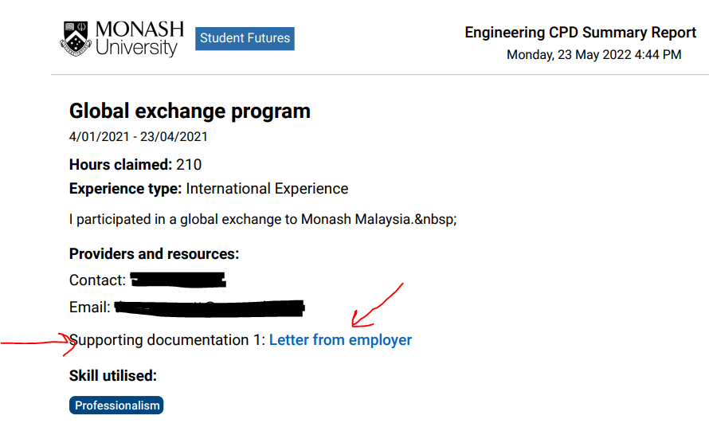

If you need instructions on how to upload your supporting documentation to Student Futures, please [click here](https://docs.google.com/document/d/1XLn0aCLjWUQaPVddIrp1rmOAiakJDVqr8JyoCky_JIM/edit?usp=sharing).

**Guidelines for Supporting Documents:**

**Supporting documents must be in English –** if your original document is not in English you should check if the supplier can reissue it to you in English. If they can’t then you must have it translated by a [NAATI certified translator](https://www.naati.com.au/) and submit both the original and the translation.

**For Monash experiences you can supply a screenshot of the unit / program listed on your WES record.**

**For External experiences the evidence you supply needs to show:**

* what the experience was (if it was a job, this should include your job title and a description of your duties)
* when it took place
* how long it went for
* that you participated in it

**If one supporting document doesn’t provide all the evidence required then please include multiple documents for that experience (payslips for example don’t usually show what your duties were, so you would need something else that shows what your role and duties were).**

Your claimed hours may be rejected if you do not supply sufficient evidence.

Suggested examples might include:

* Statements of work provided by your employers ([sample letter for work providers](https://www.monash.edu/__data/assets/pdf_file/0015/930012/OpenLettertoEmployers.pdf));
* Offers of employment or work experience;
* Sample payslips from work positions (please obscure any bank or payment details, and provide one payslip from the start and one from the end to show length of employment);
* Certificates of achievement or attendance at events;
* Screenshots showing online course completion;
* Advertising or flyers for events attended;
* Evidence of registration for professional development programs or activities;
* Photographs or images relevant to your experiences;

Please respect the privacy and confidentiality of the university, external companies and other students in selecting appropriate materials to submit. These reports will not be published or shared beyond the CPD assessment team.

**Please enter your course start-date below, list those experiences greater than 35 hours in the table, and provide the Student Future hyperlinks (found on your Engineering CPD Summary Report) for each supporting document. Please do not copy the hyperlink to your experience from the Student Futures platform webpages, you must copy the hyperlink from your Engineering CPD Summary Report (if needed, please see the instructions above on how to find the correct hyperlinks).**

I confirm that I started my Monash Engineering course in (please enter Month, Year): __________________

|  |  |  |  |  |  |  |  |
| --- | --- | --- | --- | --- | --- | --- | --- |
| **List all your CPD Experiences greater than 35 hours duration that you have claimed on Student Futures, and include the hyperlink(s) to the supporting documentation (you will find the hyperlinks in your Engineering CPD Summary Report)** | | | | | | | |
| **Dates of your experience** | **Monash year level when completed** | **Company / Activity / Unit Code** | **Position/Role** | **Engineering or Non-Engineering?** | **Curriculum-based Y/N** | **# of Hours** | **Hyperlink(s) to supporting document(s) copied from your Engineering CPD Summary Report** (do not copy the hyperlink from the Student Futures website, only from the CPD Summary Report document) |
|  |  |  |  |  |  |  |  |
|  |  |  |  |  |  |  |  |
|  |  |  |  |  |  |  |  |
|  |  |  |  |  |  |  |  |
|  |  |  |  |  |  |  |  |
|  |  | Add rows if needed |  | Delete excess rows |  |  |  |

Before you submit the information above, please open an incognito window and check that each hyperlink is working correctly and linking to the right document.

If for some reason you are unable to link to your supporting documentation, please indicate this in the table above and insert a screenshot of your proof below.